**GAURAV TIWARI | MCADS1 | Class roll no. 19 | 10/08/23 |**

**Assignment 1**

1. Create a function that takes a number as it’s only argument and returns true if it is less than or equal to 0,otherwise return false.

<html>

<head>

<script>

function myfun(){

var num = (document.f1.n1.value);

if(num <=0){

document.writeln("True"); }

else{

document.writeln("False"); } }

</script>

</head>

<body>

<form name="f1">

<h3>num<=0 -- True! Enter a number..</h3>

<input type="number" name="n1">

<input type="button" value="Check" onClick="myfun()" id="button">

</form>

<style>

#button{

border-radius: 20px;

font-size: large; }

</style> </body> </html>

----------------------------------------------------------------------------------------------------------

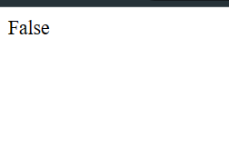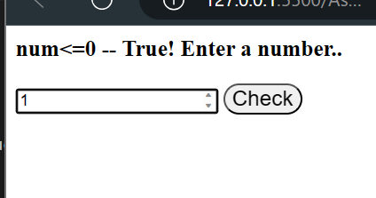**Output :**

1. Write a JavaScript program to find the area of a triangle.

<html>

<head>

<script>

function myfun(){

var base = (document.f1.n1.value);

var height = (document.f1.n2.value);

var area = 1/2* base* height;

document.writeln("Area of triangle is : ",area); }

</script>

</head>

<body>

<form name="f1">

<h3>Enter base of triangle </h3>

<input type="number" name="n1"> <br> <h3> Enter height of triangle </h3>

<input type="number" name="n2"> <input type="button" value="Area of 📐" onClick="myfun()">

</form>

<style>

#button{

border-radius: 20px;

font-size: large; }

</style>

</body> </html>

----------------------------------------------------------------------------------------------------------

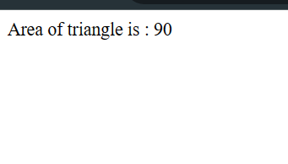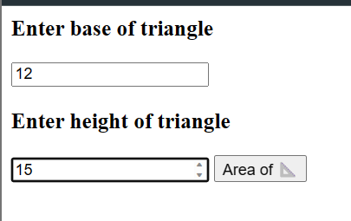 **Output :**

1. Write a JavaScript program to determine whether a given year is a leap year .

<html>

<head>

<script>

function myfun(){

var year = (document.f1.n1.value);

if( year%4==0){

document.writeln(year,"is a leap year"); }

else{

document.writeln(year," is not a leap year"); }}

</script>

</head>

<body>

<form name="f1">

<h3>Enter a year to check leap year or not ..</h3>

<input type="number" name="n1">

<input type="button" value="Check" onClick="myfun()">

</form>

<style>

#button{

border-radius: 20px;

font-size: large; }

</style> </body> </html>

----------------------------------------------------------------------------------------------------------

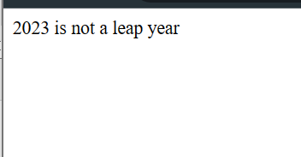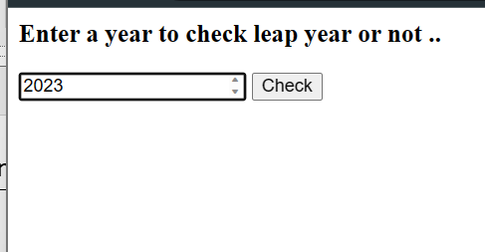**Output**

1. Create a function that takes a number as it’s only argument and returns true if it is less than or equal to 0,otherwise return false.

<html>

<head>

<script>

function myfun(){

var celcius = (document.f1.n1.value);

var fahrenheit = (document.f1.n2.value);

var f2c = (celcius * (9/5)+32);

var c2f = ((fahrenheit - 32) * 5/9);

document.writeln(fahrenheit,"° Fahrenheit to Celcius is : ",f2c+"°C");

document.writeln("||");

document.writeln(celcius,"° Celcius to Fahrenheit is : ",c2f+"°F"); }

</script>

</head>

<body>

<form name="f1">

<h3>Enter temperature in Fahrenheit</h3>

<input type="number" name="n2">

<br> <h3> Enter temperature in Celcius</h3>

<input type="number" name="n1">

<input type="button" value="Check" onClick="myfun()">

</form> </body> </html>

----------------------------------------------------------------------------------------------------------

**Output :**

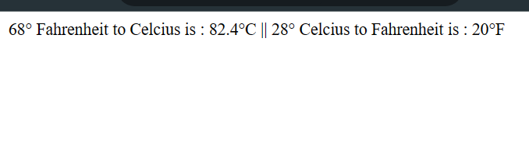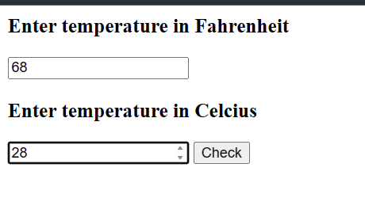

1. Write a JavaScript function that returns array elements larger than a number.

<html>

<head>

<script>

function myfun() {

var numbers = document.f1.n1.value.split(',').map(Number);

var num = Number(document.f1.n2.value);

var result = [];

for (var i = 0; i < numbers.length; i++) {

if (numbers[i] > num) {

result.push(numbers[i]); } }

document.writeln("Array elements larger than " + num + ": " + result.join(', ')); } </script>

</head>

<body>

<form name="f1">

<h3>Enter comma-separated numbers..</h3>

<input type="text" name="n1">

<h3>Enter a number..</h3>

<input type="number" name="n2">

<input type="button" value="Check" onClick="myfun()" id="button">

</form> </body> </html>

----------------------------------------------------------------------------------------------------------

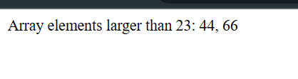**Output :**

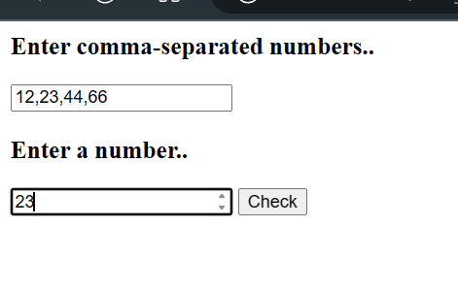

1. Write a JavaScript conditional statement to sort three numbers. Display an alert box to show the result.

<html>

<head>

<script>

function myfun() {

var num1 = parseFloat(document.f1.n1.value);

var num2 = parseFloat(document.f1.n2.value);

var num3 = parseFloat(document.f1.n3.value);

var sortedNumbers = [num1, num2, num3].sort(function(a, b) {

return a - b;

});

alert("Sorted numbers: " + sortedNumbers.join(', '));

}

</script>

</head>

<body>

<form name="f1">

<h3>Enter three numbers..</h3>

<input type="number" name="n1"> <br>

<input type="number" name="n2"> <br>

<input type="number" name="n3"> <br>

<input type="button" value="Sort" onClick="myfun()" id="button">

</form>

</body> </html>

----------------------------------------------------------------------------------------------------------

**Output :**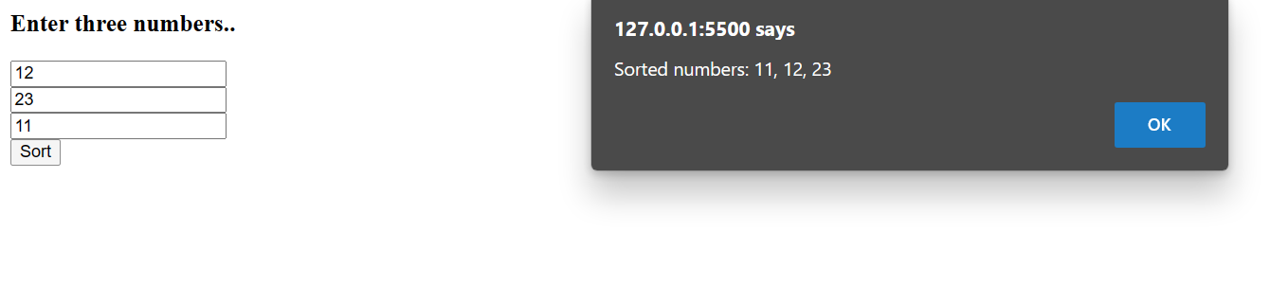

1. Write a JavaScript program which compute, the average marks of the following students Then, this average is used to determine the corresponding grade. The grades are computed as follows :

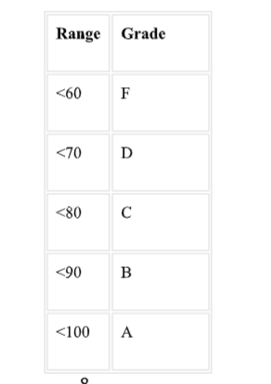

<html>

<head>

<script>

function myfun(){

var DL = parseFloat(document.f1.n1.value);

var AI = parseFloat(document.f1.n2.value);

var CSS = parseFloat(document.f1.n2.value);

var IOT = parseFloat(document.f1.n2.value);

var BDA = parseFloat(document.f1.n2.value);

var avg = ((DL+AI+CSS+IOT+BDA)/500)*100;

if (avg < 60) {

confirm(avg+" is average marks out of 5 subjects and Grade is : F");

} else if (avg < 70) {

confirm(avg+" is average marks out of 5 subjects and Grade is : D");

} else if (avg < 80) {

confirm(avg+" is average marks out of 5 subjects and Grade is : C");

} else if (avg < 90) {

confirm(avg+" is average marks out of 5 subjects and Grade is : B");

} else {

confirm(avg+" is average marks out of 5 subjects and Grade is : A"); } }

</script>

</head>

<body>

<form name="f1">

<h3>Enter marks of 5 subjects</h3>

<h4> DL</h4>

<input type="number" name="n1">

<h4> AI</h4>

<input type="number" name="n2">

<h4> CSS</h4>

<input type="number" name="n3">

<h4> IOT</h4>

<input type="number" name="n4">

<h4> BDA</h4>

<input type="number" name="n5"> <br> <br>

<input type="button" value="Check Grade" onClick="myfun()">

</form> </body> </html>

----------------------------------------------------------------------------------------------------------

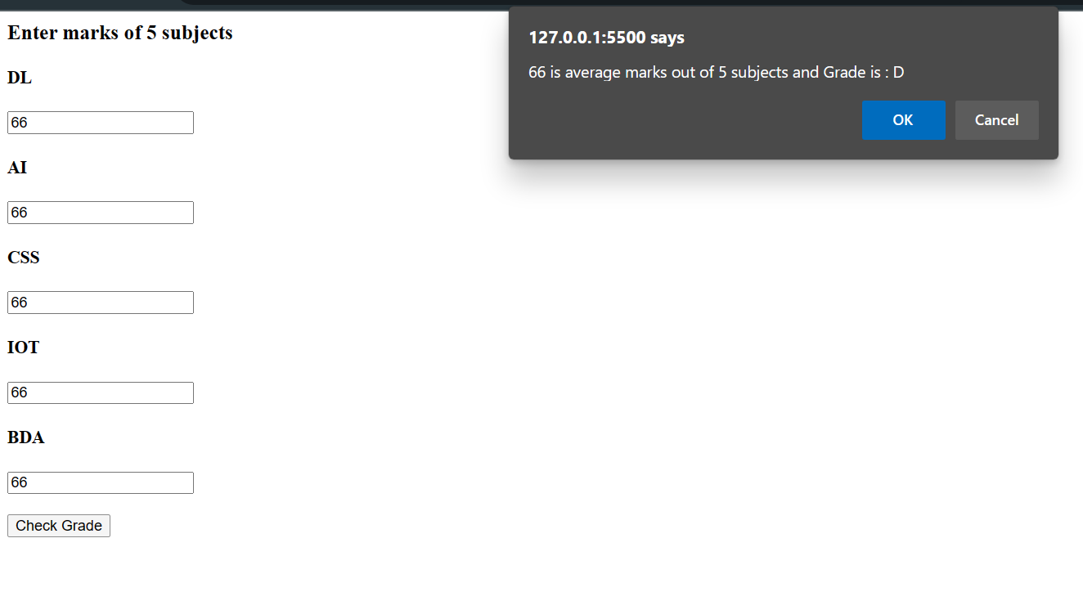**Output :**